**CHATBOT IN PYTHON**

A Project Report Submitted in Partial Fulfillment of the Requirement for the Award of the Degree of

**BACHELOR OF TECHNOLOGY (CSE)**

**to**



**By**

**Saksham thakur(11909528)**

**Anubhav Chauhan(11909541)**

**Under the Guidance of**

**Mr. Sagar pande(23754)**

**On**

**NOVEMBER-2020**

**ACKNOWLEDGEMENTS:-**

**____________________________________________________** It is indeed a great pleasure to express our sincere thanks to our august supervisor **Mr. SAGAR PANDE.** He was always there to listen and to give advice. He showed us different ways to approach a research problem and the need to be persistent to accomplish any goal. He taught us how to write academic paper, had confidence in us when we doubted ourselves, and brought out the good ideas in us. He was always there to meet and talk about our ideas, to proofread and mark up our paper, and to ask us good questions to help us think through our problems. Without his encouragement and constant guidance, we could not have finished this project. Last, but not least, we thank our parents, for giving us life in the first place, for educating us with aspects from both arts and sciences, for unconditional support and encouragement to pursue our interests. We dedicate this work to our parents who will feel very proud of us. They deserve real credit for getting us this far, and no words can ever repay for them.

**-SAKSHAM THAKUR**

**-ANUBHAV CHAUHAN**

**LIST OF ABBREVIATIONS:-**

**____________________________________________________** ACH-- Automated Clearing House

ISP-- Internet service provide

OCC-- Open Cash Credit

ATM --Automatic Teller Machine

JDBC --Java Database Connectivity

JSP --Java Server Page

HTML --Hypertext Markup Language

CSS --Cascading Style Sheet

IDE --Integrated Development environment

DFD --Data flow Diagram

UML --Unified Modelling language

SQL --Structure Query Language

DML --Data Manipulation Language

GUI Graphic User Interface

J2SDKD Java 2 SDKD

HTTP Hypertext Transfer protocol

**CONTENTS:-**

**____________________________________________________**

**INTRODUCTION:-**

**____________________________________________________** A chatbot is a computer program that can converse with humans using artificial intelligence in messaging platforms. It has its own account management system with the ability to set up groups that have discussions boards. Groups are collections of users that have access to a group feed. Over past few years, messaging applications have become more popular than Social networking sites. People are using messaging applications these days such as Facebook Messenger, Skype, Viber, Telegram, Slack etc. This is making other businesses available on messaging platforms leads to proactive interaction with users about their products. To interact on such messaging platforms with many users, the businesses can write a computer program that can converse like a human which is called a chatbot. Chatbots come in two kinds: • Limited set of rules • Machine learning Chatbot that uses limited set of rules This kind of bots are very limited to set of texts or commands. They have ability to respond only to those texts or commands. If user asks something different or other than the set of texts or commands which are defined to the bot, it would not respond as desired since it does not understand or it has not trained what user asked. These bots are not very smart when compared to other kind of bots.

**REQUIREMENTS AND SPECIFICATION:-**

**____________________________________________________** **Hardware Requirements:**

* Processor : Pentium IV(minimum)
* RAM : 256MB (minimum)

**Software Requirements:**

* Operating System : Windows or Linux
* Technology : PYTHON

**IMPLEMENTATION**

**____________________________________________________** This section covers the design and implementation of different module of the bot, which contains the design of the PYTHON module.

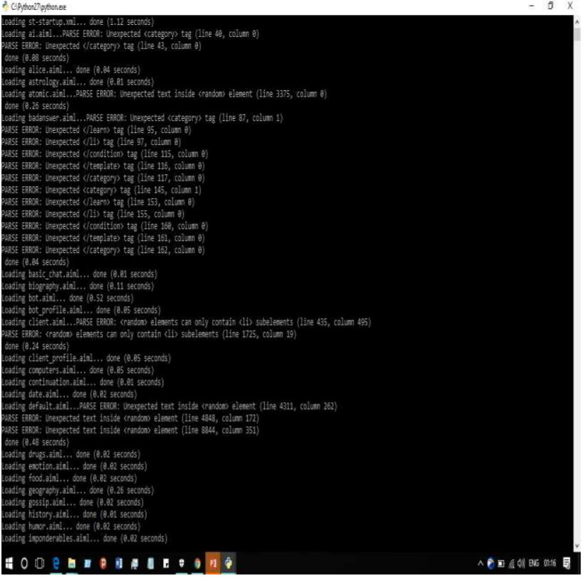

**Fig 6.1 Execution of main file**

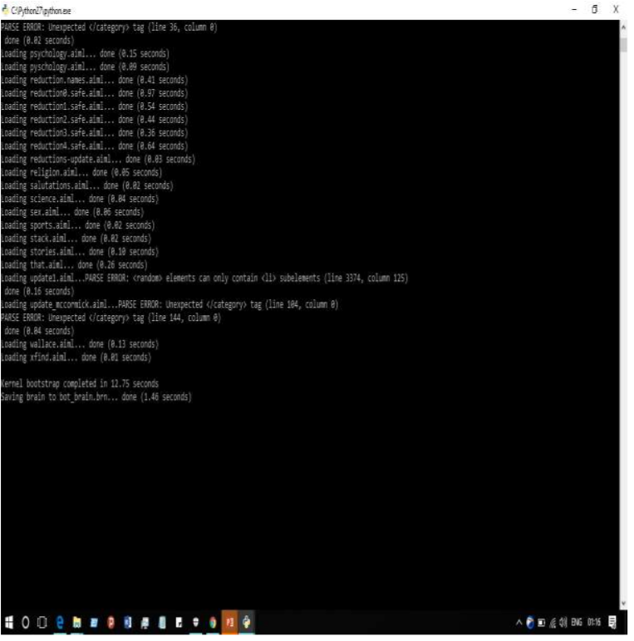

**Fig 6.2 Continue**

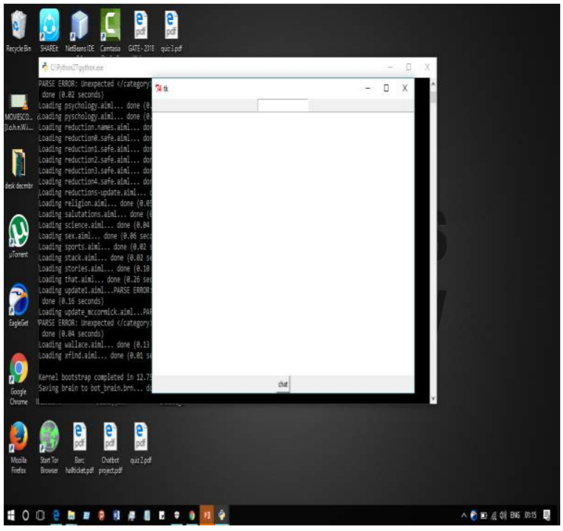

**Fig 6.3 Chatbot Interface**

***ADVANTEGEs:-***

***___________________________________________________***

**Advantages:-**

**1. Accessible anytime:** I’m sure most of you are always kept on hold while operators connect you to a customer care executive. On an average people spend around 7 minutes until they are assigned to a person.

**2. Handling Capacity:** Unlike humans who can only communicate with one human at a time, chat bots can simultaneously have conversations with thousands of people. No matter what time of the day it is or how many people are contacting you, every single one of them will be answered immediately.

**3. Cost Effective:** Hiring a human for a job is never a cheap affair, and it will be expensive if your revenue are not high or sales targets are not met and would create havoc in the business. Due to the boundaries of human beings, a single human can only handle one or two people at the same time. More than that would be extremely tough for the employee.

***CONCLUSION AND FUTURE SCOPE***

***____________________________________________________*** Chatbots are the new Apps! As we have discussed in the above deliverables. By implementing the above mentioned deliverables we were able to add a basic chatbot functionality. I intend to enhance the system developed so far. Next step towards building chatbots involve helping people to facilitate their work and interact with computers using natural language or using set of rules.. Future chatbots, backed by machine-learning technology, will be able to remember past conversations and learn from them to answer new ones. The challenge would be conversing with multiple bot users and multiple user.

***Future Scope:-***

There are limitations to what has been currently achieved with chatbots. The limitations of data processing and retrieval are hindering chatbots to reach their full potential. It is not that we lack the computational processing power to do so. However, there is a limitation on “How” we do it. One of the biggest examples is the retail customer market. Retail customers are primarily interested in interacting with humans because of nature of their needs. They don’t want bots to process their needs and respond accord.

***References:-***

***____________________________________________________***